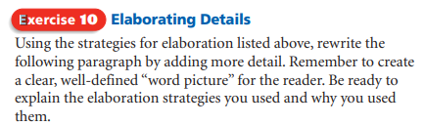
My day is filled with activity. I wake up very early, eat breakfast, and go to school. Once in the classroom, I am on a very tight schedule. Each class has its own routine. I am glad when the lunch bell finally rings because I finally have time to relax. However, all too soon lunch is over and I am in the classroom for the rest of the afternoon. When school is out, I go home, eat, do my homework, and go to bed. The next day, I do it all again.

